

MS Bookings Appointment Reservation Instructions – Enrollment in Forms of support
Project: „Improving Academic Efficiency: University Management and Drop-out Reduction”.
The project is implemented within the European Funds for Social Development Program 2021 2027, co-financed from the European Social Fund Plus.
Access the reservation page
Open the link assigned to a specific Form of support:
- Consultation with the Specialist for Academic Community Integration,
- Support groups,
- Individual psychological sessions,
- Individual coaching sessions.
Note: To enroll in Support groups, individual psychological sessions or individual coaching sessions, you must first schedule a consultation with the Specialist for Academic Community Integration.
Select the language of the service
On the page, you will see tiles with the names of the services, e.g.:
- „Konsultacja ze Specjalistą ds. integracji społeczności akademickiej” (Polish)
- „Consultation with the Specialist for Academic Community Integration” (English)
Click on the selected option.
(Optional) Select the Staff member
For some Forms of support, you can choose the staff member you want to have the consultation with. If this option appears, select your preferred Staff member from the drop-down list. If not, the system will assign a staff member automatically.
Select the appointment date and time
After selecting the service, the calendar will appear.
Choose a convenient date and time from the slots available according to the schedule of the persons providing the selected Form of support.
Note: Reservations can only be made at least 72 hours before the scheduled appointment.

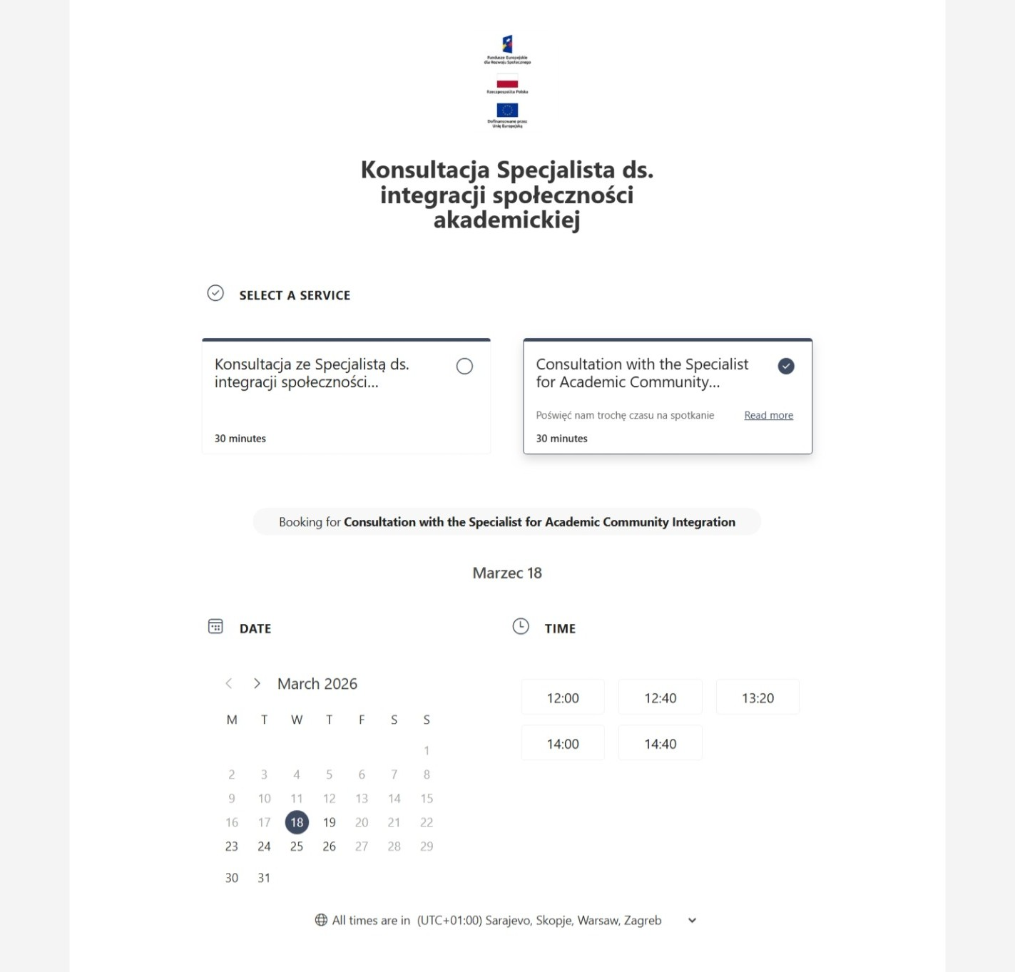
Fill in your details
In the form, please enter:
- Your first and last name
- E-mail address (use your student e-mail address)
- Phone number
Other fields are optional.
If you have any special needs (e.g., wheelchair access, need for a PJM interpreter, bringing a child), enter them in the field: „Add any special requests”.
Select the preferred form of support delivery
From the drop-down list, please choose:
- Remote (MS Teams) or
- In-person meeting
Note: This is a preference, not a guarantee of the form of delivery.
Reserve the appointment
Check the accuracy of the entered information, and then click „Book” button.
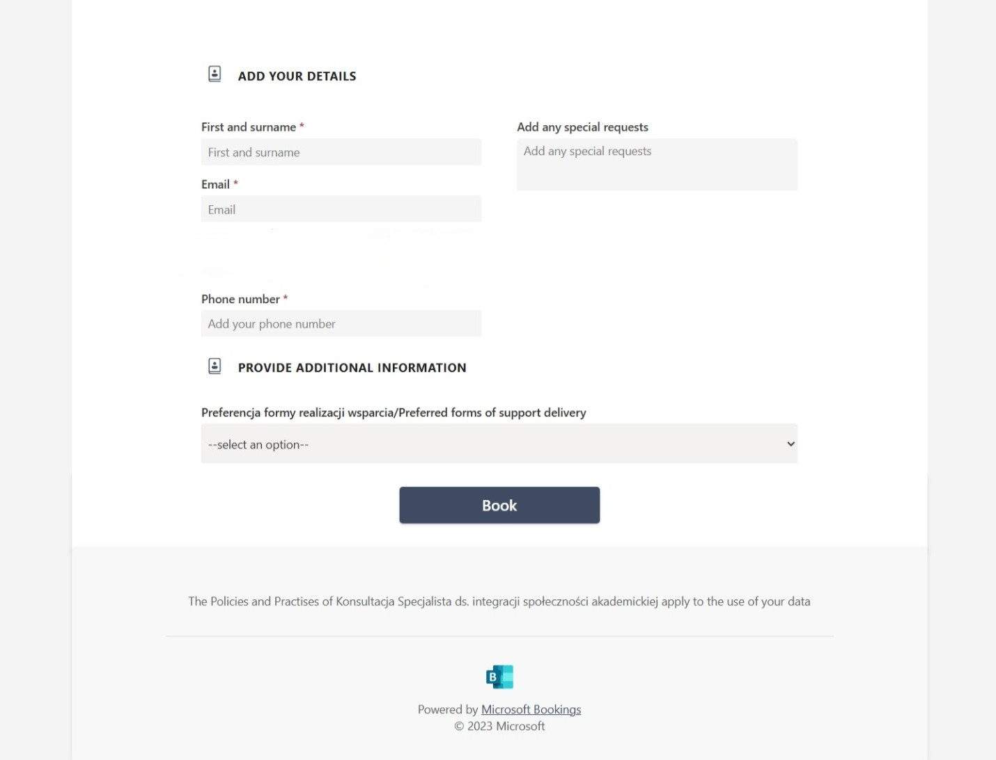
Reservation confirmation
After clicking, a message will appear:
„Thank you for booking with us! You will get a confirmation message in email shortly”
You will also see a summary of your reservation (date and time).
At this point, you can:
- Change the appointment date,
- Cancel the reservation,
- Create a new reservation.
Note: Changing or cancelling a reservation is only possible at least 72 hours before the scheduled appointment.

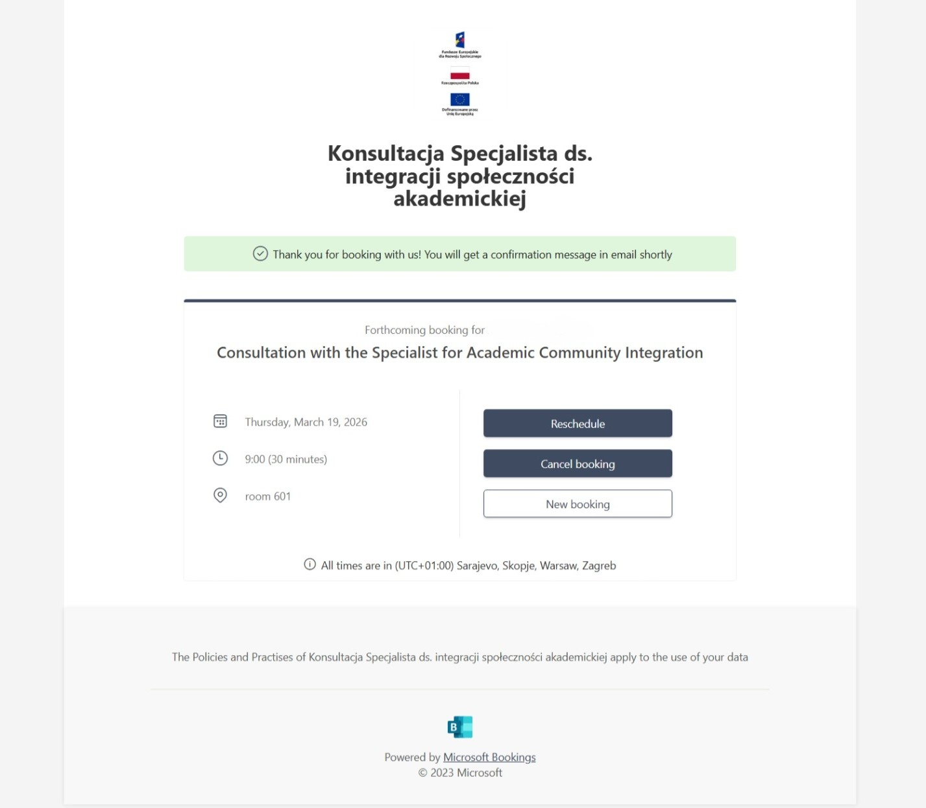
Check your e-mail inbox
Within a few minutes, you will receive a confirmation e-mail containing:
- Name of the service,
- Name of the Staff member,
- Appointment date and time,
- Location/form of support delivery
If you do not see the message, please check the SPAM/TRASH/OTHER folders.
Stay in touch
Regularly check your e-mail inbox. The Staff member may contact you to clarify details of the appointment.

Technical support
In case of problems with the recruitment system or have questions regarding the recruitment process, please contact the Project Staff.

Communication channels:
- Direct contact
Staff are available Monday through Friday from 9:00 a.m. to 3:00 p.m. at the European Project Department, 6th floor, room 614.
- Telephone contact
+48 22 536 54 53
- E-mail contact
projektyeuropejskie@vizja.pl

