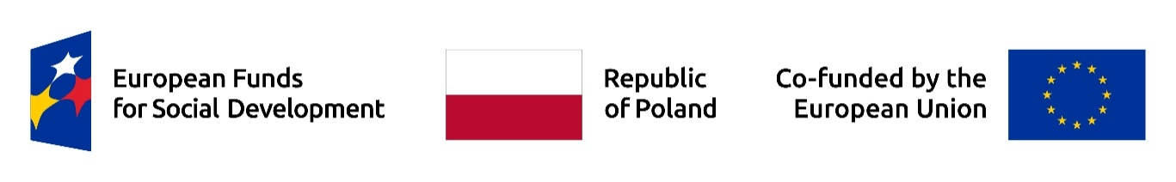

Registration instructions in the Recruitment System – Enrollment in Forms of support
Project: „Improving Academic Efficiency: University Management and Drop-out Reduction”.
The project is implemented within the European Funds for Social Development Program 2021-2027, co-financed from the European Social Fund Plus.
Table of contents
1. Purpose of the application in the system 1
2. Creating an account 2
3. Registration and completing the form 2
Step 1: Contact details 2
Step 2: Personal information 3
Step 3: Selection of Forms of support 3
4. Required consents and declarations 4
5. Submission of the recruitment form 5
6. Logging into the account 5
7. Technical support 6

1. Purpose of the application in the system
The purpose of registration in the system is to sign up for Forms of support offered within the project entitled: „Improving Academic Efficiency: University Management and Drop-out Reduction” implemented by VIZJA University. The project is implemented within the European Funds for Social Development Program 2021-2027, co-financed from the European Social Fund Plus.
In the system you can express your interest in participating in various Forms of support, such as:
- Individual coaching sessions in Polish and English,
- Individual psychological sessions in Polish and English,
- Support groups in Polish and English.

2. Creating an account
To start the recruitment process, you must create an account in the system. Go to the registration platform and click the „Register” button to access the registration form.
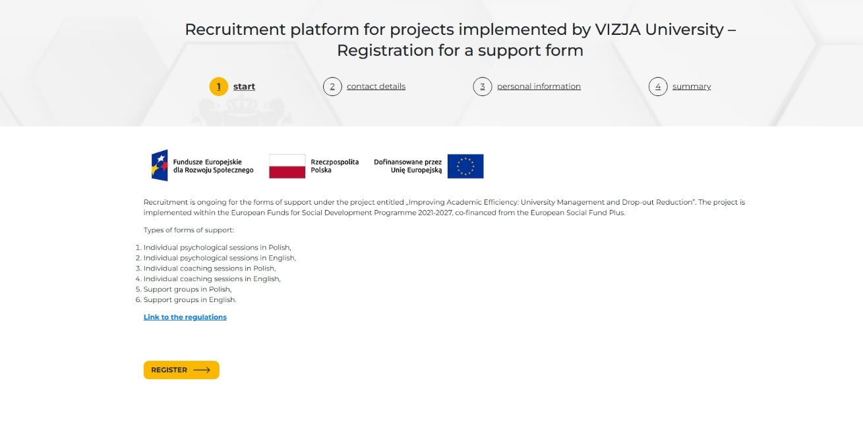

3. Registration and completing the form
After clicking „Register”, the system will guide you through the following registration steps. Make sure to complete all fields in the form.

Step 1: Contact details
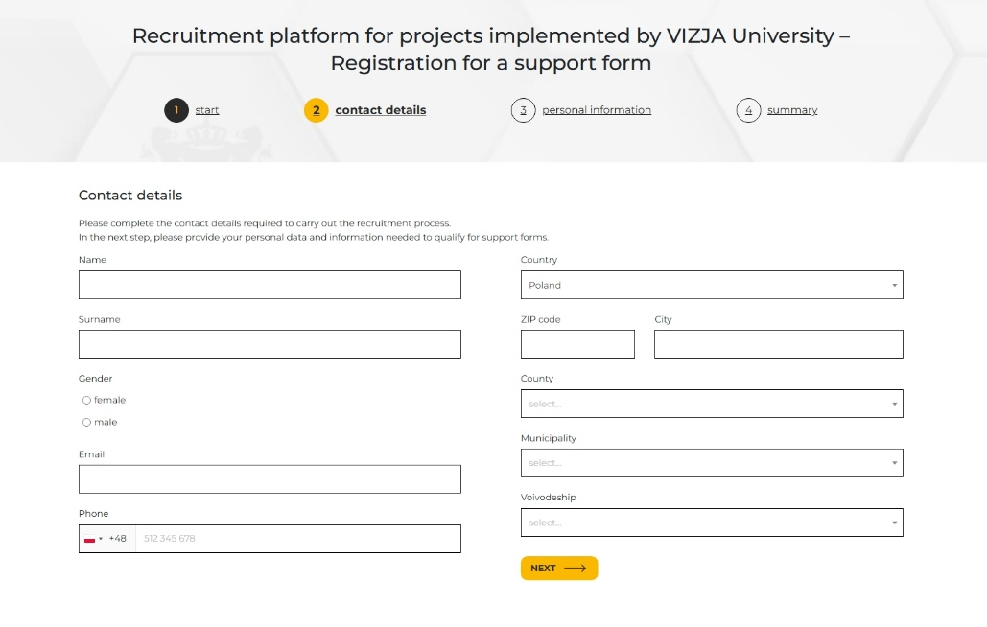
In this step, enter your contact information, such as first name, last name and phone number.

After filling in all the required fields, click „Next”.

Step 2: Personal information
In this step, enter details about your personal data, such as date of birth, citizenship, information about your studies, employment or special needs (if applicable). Some questions are scored and affect only the ranking order if the number of candidates exceeds the numer of available places.
After completing all fields, click „Next”.
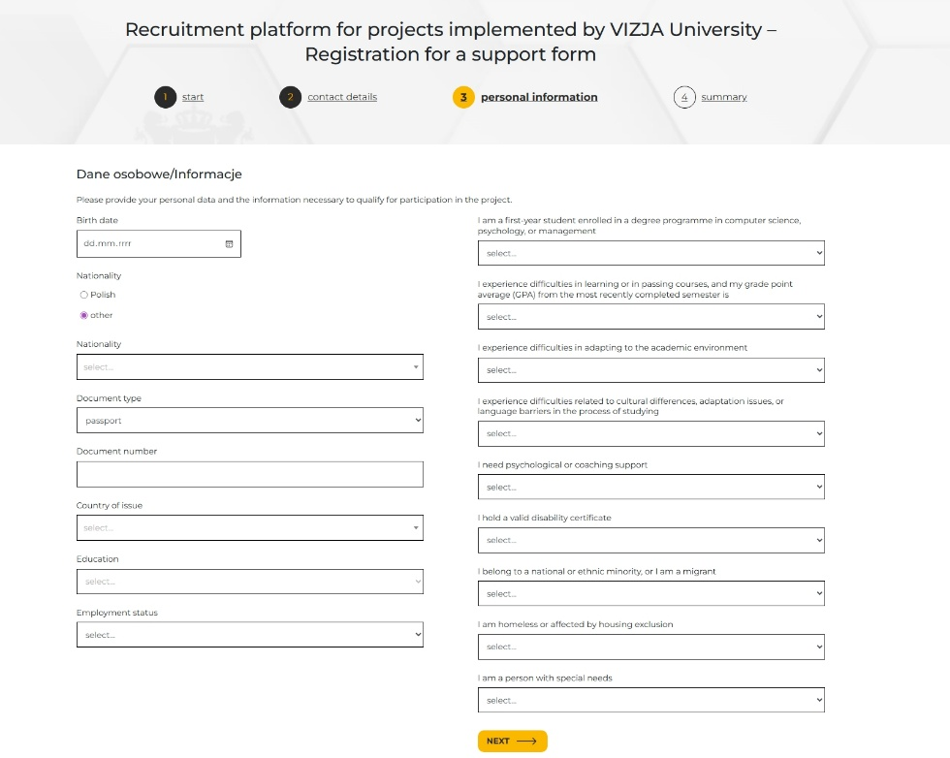

Step 3: Selection of Forms of support
At this stage, select the Forms of support you wish to participate in:
- Individual psychological sessions in Polish,
- Individual psychological sessions in English,
- Individual coaching sessions in Polish,
- Individual coaching sessions in English,
- Support groups in Polish,
- Support groups in English.
You may select more than one option – choose those that best match your needs.
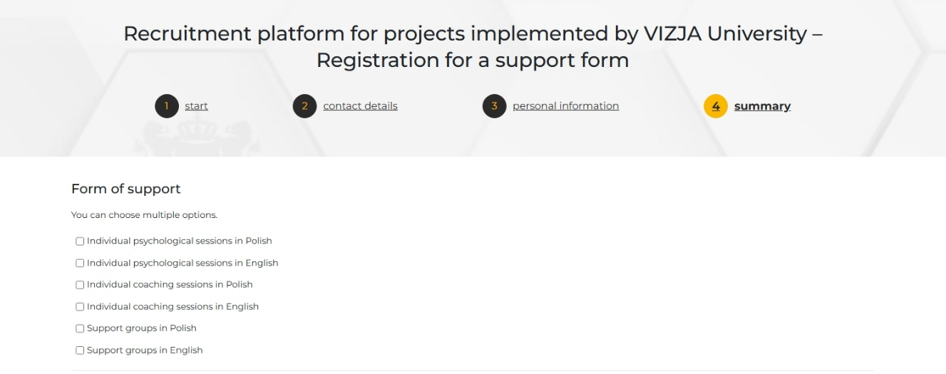

4. Required consents and declarations
Przed złożeniem formularza należy zaakceptować wszystkie wymagane zgody i oświadczenia, które są niezbędne do udziału w projekcie:
- Declaration of participation in the project – Consent to participate in the FERS 2021-2027 project.
- Confirmation of meeting recruitment criteria; consent to participate in survey research – during and after the project.
- Acceptance of the Data Privacy Notices of VIZJA University, the National Centre of Research and Development, and the Minister for Regional Development – acknowledging information on personal data processing.
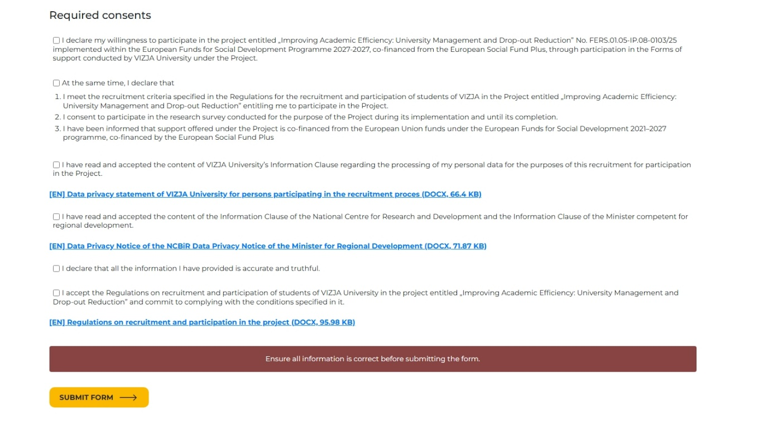
- Acceptance of the Regulations – consent to the terms specified in the regulations.
Failure to accept any of the required consents will prevent submission of the form.

5. Submission of the recruitment form
After completing the form and accepting the required consents, proceed to the summary.
Carefully check the accuracy of the entered data. If all information is correct, click „Next” to complete the registration process and submit the form.
After submitting the recruitment form, you will receive an email with an activation link. To confirm registration (authorize the form), click the „Confirm registration” button in the email.
NOTE: The Participant’s form has the form of a document, i.e., it is electronically authorized by the Participant submitting the form. Submitting it in the system via the Participant’s individual account is equivalent to providing the originals to the Project Office.
After account activation, you will receive another email containing:
- Login link,
- Individual login,
- Password for system access.
If you do not receive the message within a few minutes, please check your SPAM/JUNK/OTHER folder.

6. Logging into the account
After completing registration process, you can log into your account to:
- Monitor recruitment status,
- Upload and download required documents (e.g., disability certificate – if applicable),
- View announcements,
- Update your personal information.
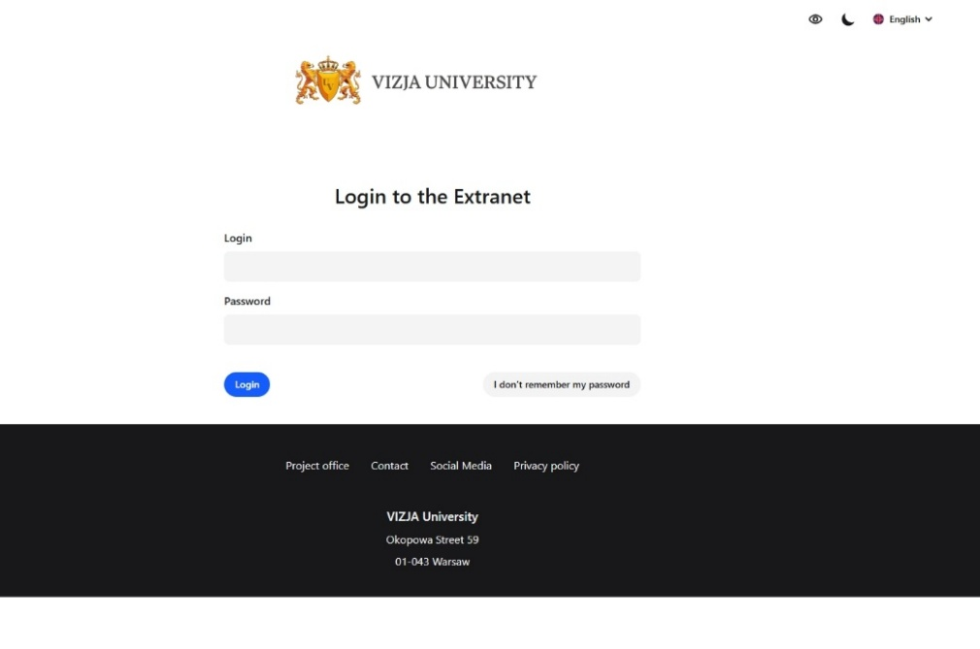

7. Technical support
In case of problems with the recruitment system or have questions regarding the recruitment process, please contact the Project Staff.
Communication channels:
- Direct contact – Staff are available Monday through Friday from 9:00 a.m. to 3:00 p.m. at the European Project Department, 6th floor, room 614.
- Telephone contact – +48 22 536 54 53.
- E-mail contact – projektyeuropejskie@vizja.pl.

