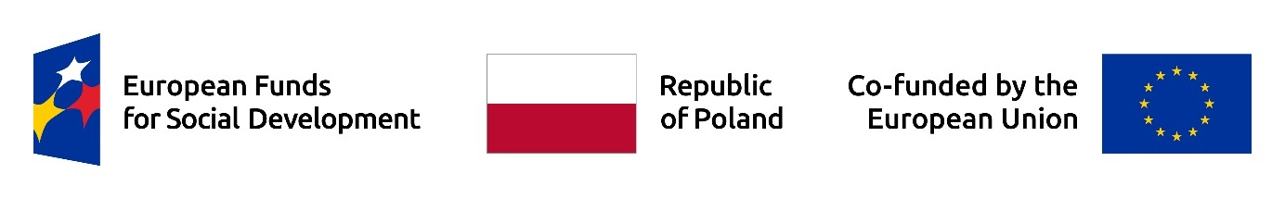
Warsaw, 20.03.2026
Document version: No. 1

Schedule of the provision of support under the project entitled “Improving Academic Efficiency: University Management and Drop-out Reduction”

Basic information:
- The project entitled „Improving Academic Efficiency: University Management and Drop-out Reduction” (project number: FERS.01.05-IP.08-0103/25) is implemented under the European Funds for Social Development 2021–2027 program and is co-financed by the European Social Fund Plus.
- This document has been prepared in accordance with the principles for creating electronic documents specified in the document entitled “Annex No. 2: Accessibility Standards for Cohesion Policy 2021–2027.” If you experience any difficulties in reading, understanding, or have other specific needs related to analyzing the content of this documentation, please report them to projektyeuropejskie@vizja.pl or by phone at +48 22 536 54 53.
- Detailed information about the project is available on the VIZJA University website in the section dedicated to the project description.
Due to the individual nature of the support forms provided under the project, i.e., individual psychological sessions and individual coaching sessions, registration for these forms of support is conducted via the Microsoft Bookings platform.
To schedule an appointment, please use the appropriate link provided below:
Individual psychological sessions: MS Booking link - to schedule an individual psychological session, please click here
Individual coaching sessions: MS Booking link - to schedule an individual coaching session, please click here
Support groups: MS Booking Link - to schedule a support group session, please click here
Upon opening the platform, Project Participants will have access to the current available appointments with the Specialists providing the support and will be able to book a chosen time for an individual session.
Please note that, in accordance with the Recruitment and Participation Regulations of the project entitled "Improving Academic Efficiency: University Management and Drop-out Reduction" - the ability to reserve appointments is available only to Project Participants who have successfully completed the recruitment process and have been qualified to participate in the project.

Support Provision Schedule:
Form of support | Number of hours (maximum) | Implementation period | Remarks
Individual psychological sessions in Polish | 1800 clock hours (including a limit of 1 to 8 clock hours per participant) | 20.03.2026 – 28.02.2029 | Support is provided on an individual and confidential basis. Appointment bookings are handled individually.
Individual psychological sessions in English | 450 clock hours (including a limit of 1 to 8 clock hours per participant) | 20.03.2026 – 28.02.2029 | The support is individual and confidential. Therefore, registrations are conducted on an individual basis.
Individual coaching sessions in Polish | 1080 clock hours (including a limit of 1 to 3 clock hours per participant) | 20.03.2026 – 28.02.2029 | The support is individual and confidential. Therefore, registrations are conducted on an individual basis.
Individual coaching sessions in English | 450 clock hours (including a limit of 1 to 3 clock hours per participant) | 20.03.2026 – 28.02.2029 | The support is individual and confidential. Therefore, registrations are conducted on an individual basis.
Support groups in Polish | 240 clock hours (including a maximum of 6 clock hours per group, i.e., 6 clock hours per participant) | 20.03.2026 – 28.02.2029 | The support is individual and confidential. Therefore, registrations are conducted on an individual basis.
Support groups in English | 120 clock hours (including a maximum of 6 clock hours per group, i.e., 6 clock hours per participant) | 20.03.2026 – 28.02.2029 | The support is individual and confidential. Therefore, registrations are conducted on an individual basis.

